**Firewall Assignment**

**Group Members:** Nina Onwuachi (10190678)

                                Abigail Brown (30214975)

                    Sarah Kaunain Syeda (30220873)

**Exercise 1**

1. v1.8.4

2. a.

b. 10 packets/840 bytes

c. INBOUND traffic because the ping request we sent is coming back as response.

d.

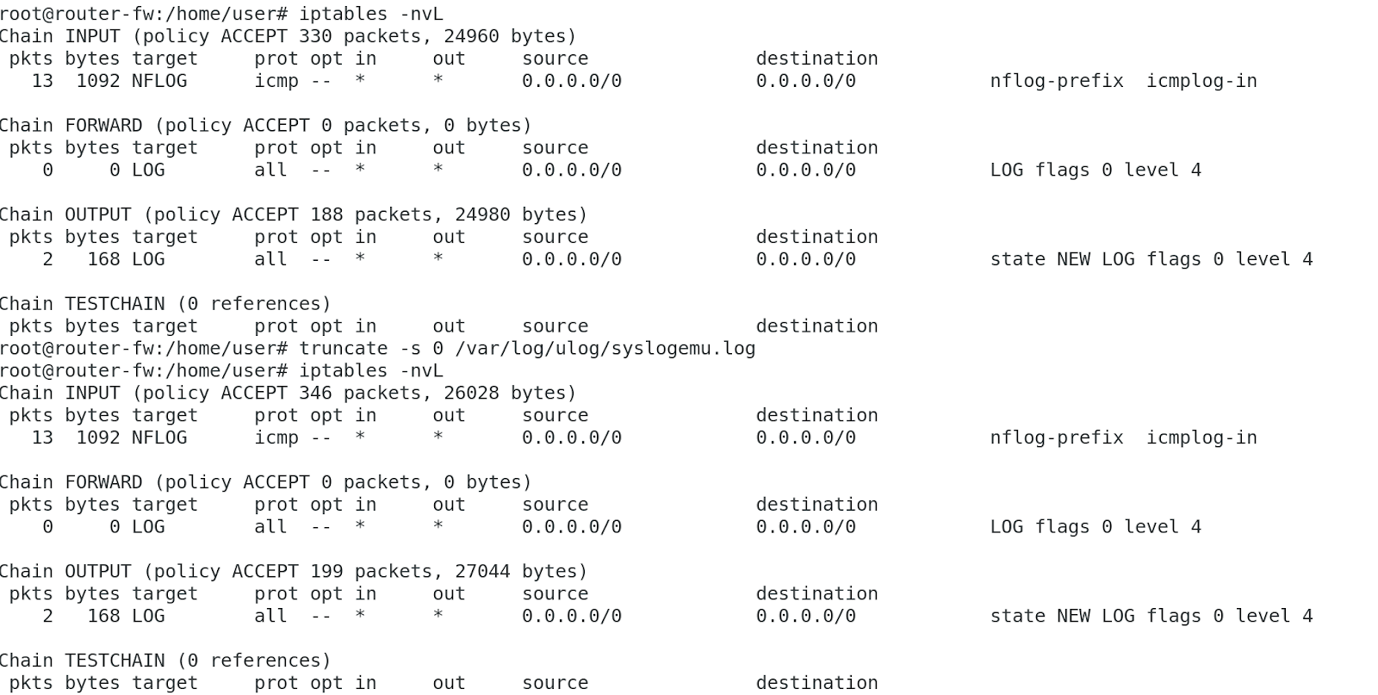

because we added an input rule and did ping which logged the input traffic. Only one command is sent by us as output so that was logged as 2, since we did ping twice.

e.

3. a.

b.

c.

4. A. iptables -A INPUT -m string --algo kmp --string "isec603" -j NFLOG --nflog-prefix "isec603found"

B. 

C. 



D. 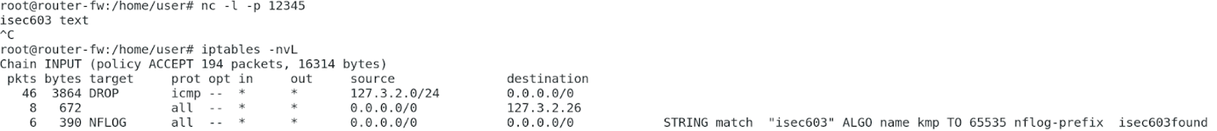

5.

1. iptables -A INPUT -p ICMP -m length --length 84 -j DROP

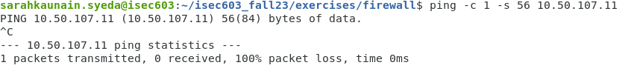

**Exercise 2**